Dear Friend,

The Spacecoast Associates for the Advancement of Zymurgy (SAAZ), your local homebrew club is proud to announce the 5th Annual Bottoms Up Beer Run. The event will take place on Saturday June 10th at 6:00pm in Wickham Park. This unique 4K race combines running (or walking) with homebrew along the way. Brewers from SAAZ will be providing 5 different homebrews for enjoyment along the course. Proceeds from the run will support SAAZ and St. Baldrick's Foundation.

We invite you to participate as a Sponsor of the Bottoms Up Beer Run. We are expecting 400 runners/walkers of all ages. This is the perfect opportunity for your business to make a contribution to two worthy organizations and advertise to hundreds of runners and walkers. Please consider supporting our cause by making a financial contribution, donate race prizes or refreshments for the post-race party. Your sponsorship helps to defray the cost of organizing the event. Any additional money from sponsorships will help go toward our fundraising goal of $5,000 to donate to St. Baldrick’s.   There are various levels of sponsorship for the Bottoms Up Beer Run. Size and placement of logos on T-shirts and web site are based on sponsorship level.

We appreciate any support that you can provide and look forward to working with you; each donation helps make this race possible. Attached you will find the sponsorship levels and sponsorship form that can be completed and submitted by mail or email.   If you have any questions or comments, please feel free to contact Anne Gregg, race director, at bottomsup@saaz.org or 321-652-1302.

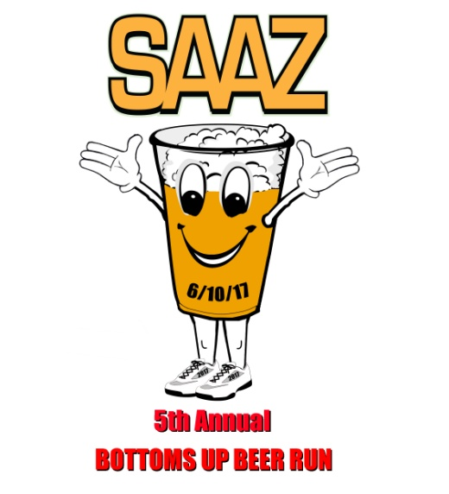Sincerely,



Anne Gregg, Race Director

**Bottoms Up Beer Run Sponsor Levels - 2017**

**Presenting Sponsorship $1,500**

1. Named as the Presenting Sponsor of the event
2. Prominent logo and/or company name on all promotions* and publicity including: press releases & 400 T-shirts (*does not include items that have already been printed)
3. Large Logo on SAAZ’s home page and the race website with Hyperlink to your website from ours
4. Banner space at Award Pavilion and signage at Start Line, Finish Line and Beer Stops (sponsor to provide banners, SAAZ will create signage)
5. Promotion on Facebook
6. Race bag inserts
7. Featured in SAAZ Newsletter with Large Logo
8. Complimentary Race Registration – 4

**Platinum Level Sponsorship $500**

1. Medium sized logo and/or company name on all promotions* and publicity including: press releases & 400 T-shirts (*does not include items that have already been printed)
2. Medium Logo on SAAZ’s home page and the race website with Hyperlink to your website from ours
3. Banner space at Award Pavilion (sponsor to provide banners)
4. Promotion on Facebook
5. Race bag inserts
6. Featured in SAAZ Newsletter with Medium Logo
7. Complimentary Race Registration – 2

**Gold Level Sponsorship $250**

1. Small sized logo and/or company name on all promotions* and publicity including: press releases & 400 T-shirts (*does not include items that have already been printed)
2. Small Logo on SAAZ’s home page and the race website with Hyperlink to your website from ours
3. Banner space at Award Pavilion (sponsor to provide banners)
4. Promotion on Facebook
5. Race bag inserts
6. Featured in SAAZ Newsletter with Small Logo
7. Complimentary Race Registration – 1

**Silver Level Sponsorship $100**

1. Company name listed on 400 T-shirts
2. Company name listed the race website with Hyperlink to your website from ours
3. Promotion on Facebook
4. Race bag inserts
5. Company name listed in SAAZ Newsletter

**Bronze Sponsorship $50**

1. Company name listed the race website
2. Promotion on Facebook
3. Race bag inserts
4. Company name listed in SAAZ Newsletter

**\*\*\* In-kind donations of goods/services will be valued at half their cash equivalent\*\*\***

Bottoms Up Beer Run Sponsorship Form

Company Name: _______________________________________________________________

Address: _________________________________________________________________________

City: ______________________________________________ State: _________ Zip: ____________

Contact person: ___________________________________________________________________

Contact email: _________________________ Phone number: _____________________

Web site address: _________________________________________________________________

1. Sponsorship level: □ Presenting □ Platinum □ Gold □ Silver □ Bronze

2. We plan to send materials/giveaways for the participant bags: □ Yes □ No

Please have 400 items ready for bag stuffing by **June 2nd**. Please let me know if I need to pick up from you or if you can deliver to the Running Zone in Melbourne.

3. We plan to include a coupon or ad in the virtual race bag: □ Yes □ No

Please send me your digital file by **June 2nd**.

4. Please write your company name exactly how you’d like it to appear on web site, signage, etc.: ______________________________________________________________________________

5. Sponsor logos should be emailed to me by **May 15th** to make the T-shirt print deadlines!

* All logos should be submitted in the highest resolution possible.
* Logos for t‐shirts will be printed only in one‐color, please send a single color logo if possible for best presentation.
* Logos for signage and website should be your full color logo.

6. Attached are your complimentary race registration forms, please email/mail back to me or you can drop off at the Running Zone. You cannot use them with online registration.

7. Please send sponsorship money in by **June 2nd**. Checks can be made payable to SAAZ and mailed to: SAAZ, 8615 Stalwart Circle, Melbourne, FL 32940. Invoice attached.

8. In-kind donation Description: ________________________________________________________________________________

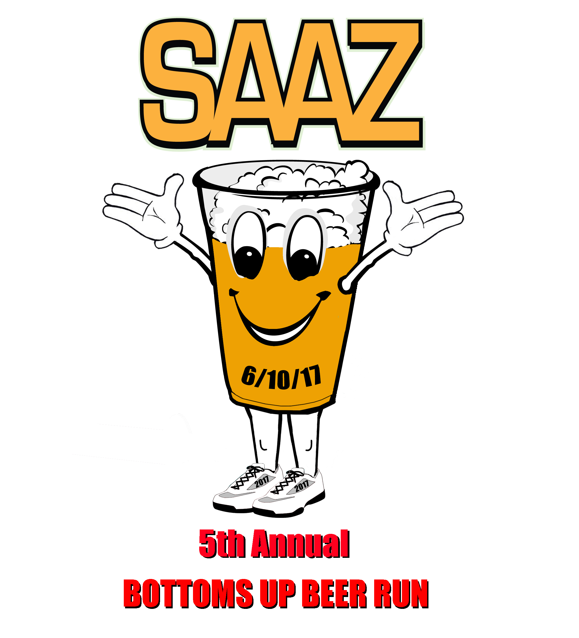

9. T-shirt Size: □ Small □ Medium □ Large □ XL □ 2XL